PRACTICAL LIST – AY: 2026- 27
Sr. no. | Title
6. | Title: Version Control for Test Scripts using GitHub  Aim: To manage automation scripts using Git.  Software Required  - Git  - GitHub  - VS Code  Procedure  - Initialize repository.  - Add scripts.  - Commit changes.  - Push to GitHub.  - Pull latest changes.  Expected Outcome: Test scripts are version controlled.  Result: Git workflow successfully completed..
Solution:
Step 1: Install & configure Git
https://git-scm.com/downloads

Verify Installation :
git --version

Set username and password :
git config --global user.name "name"
git config --global user.email "email ID"

Configuration Check
git config --list
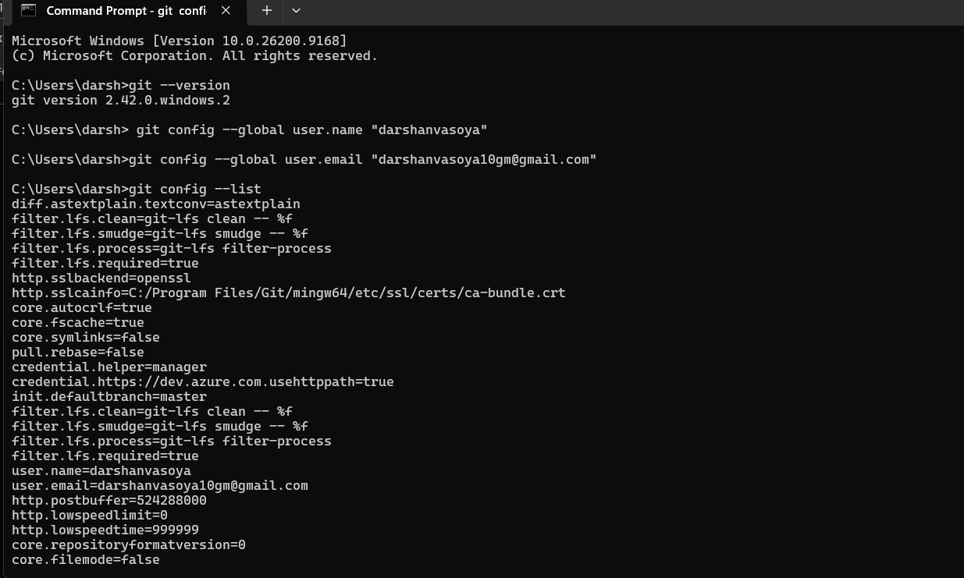

Go to github , and create new repository ,
Click new for create new repository .

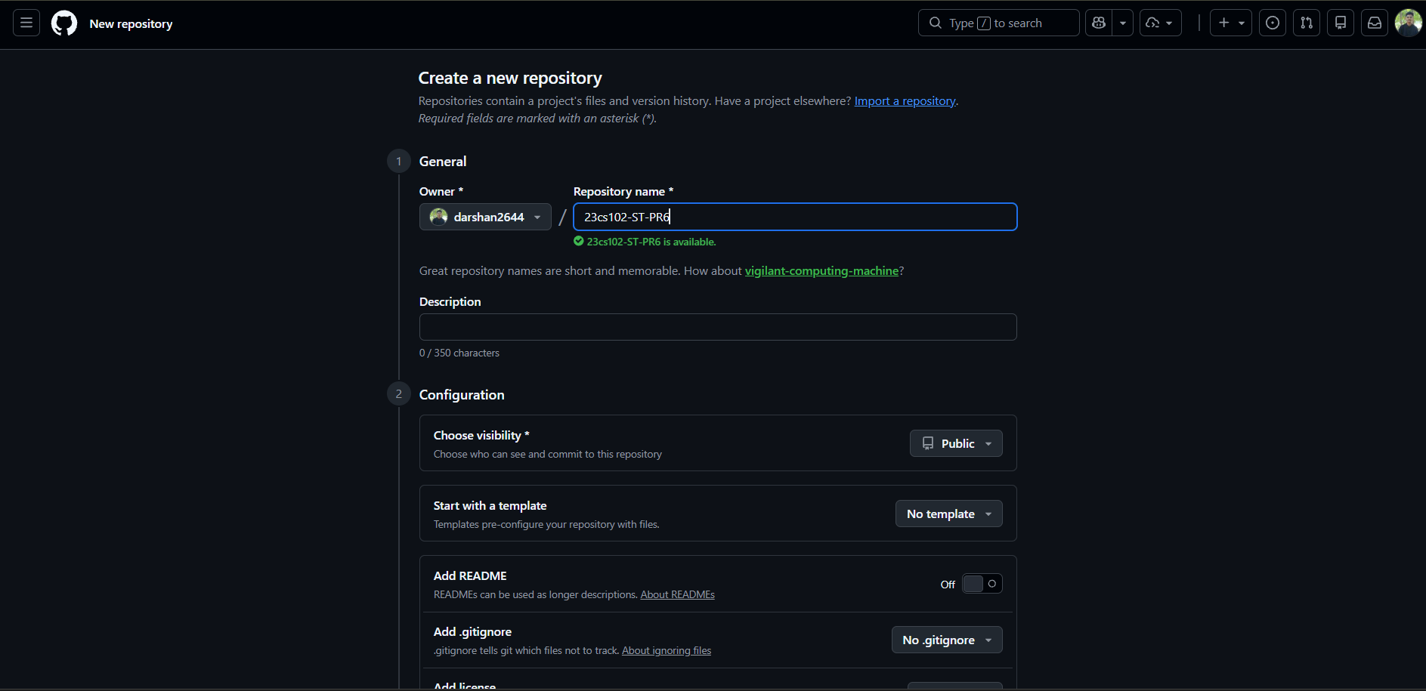
Enter name of repository and choose visibility (public/private) and Click button “Create repository”
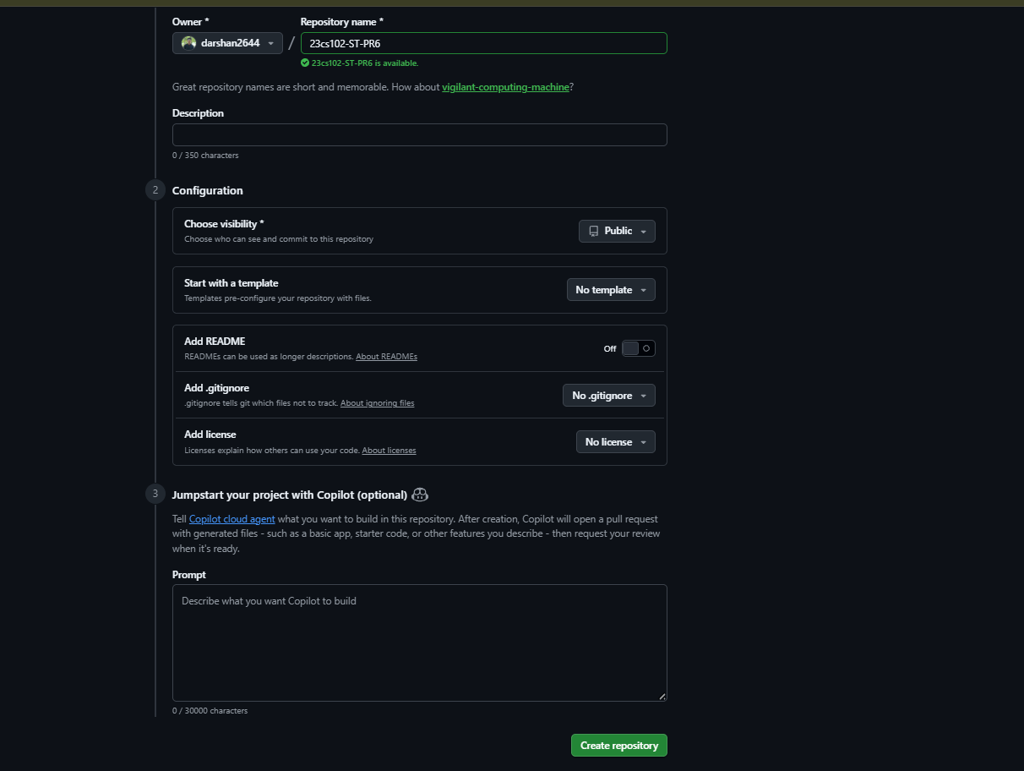
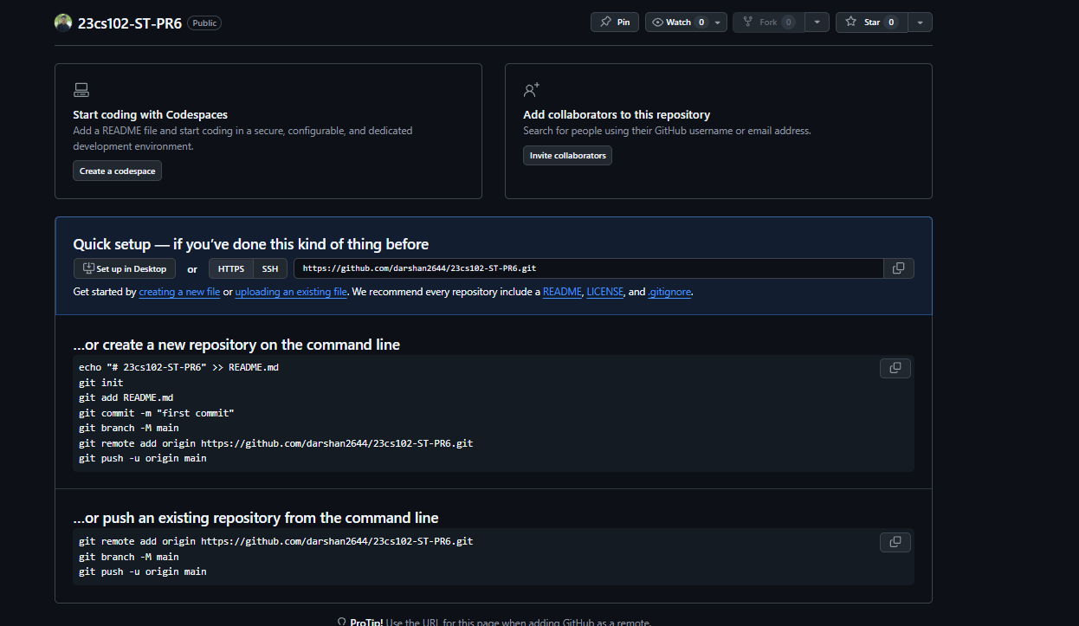
First view of repository.
Now Go to the Project folder .
git init
git add .
git commit -m "first commit"
git branch -M main
git remote add origin https://github.com/demo/Software-testing
git push -u origin main
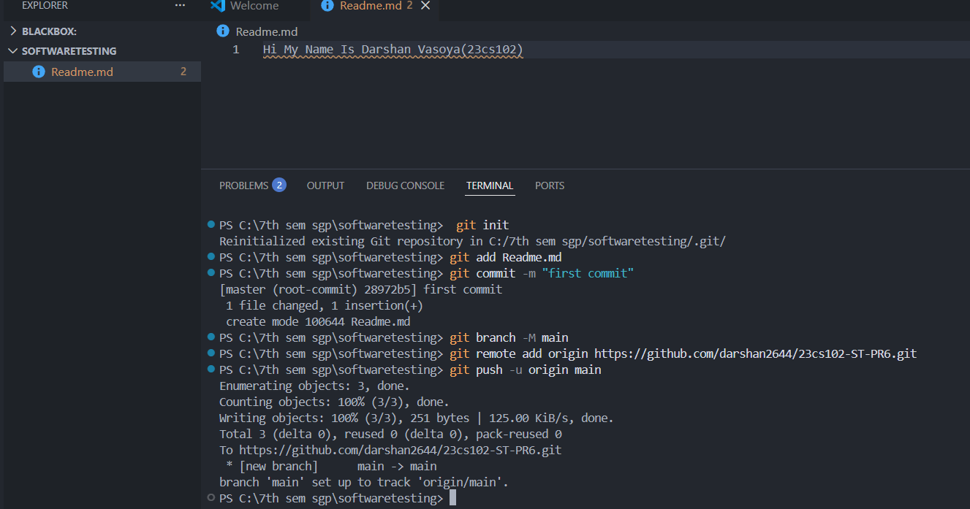

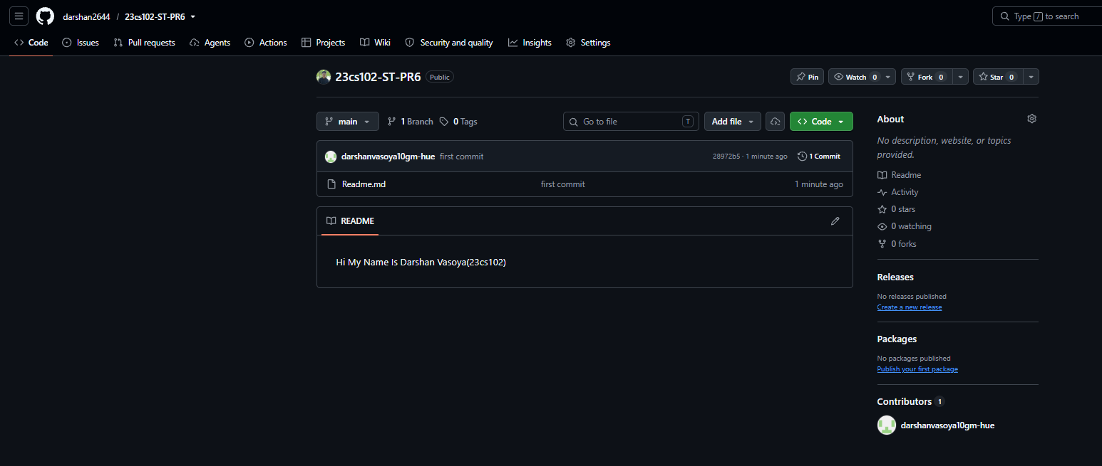
First commit is successful Done.
Now pull from github, First check remote as local machine
git remote -v
git pull origin main
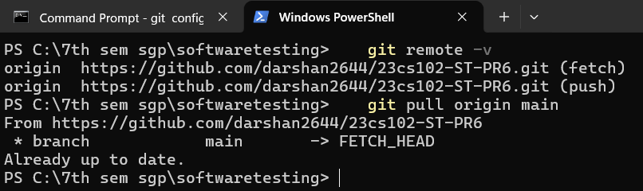

Now commit changes to Github.
git add .
git commit -m "changes Done"
git push origin main
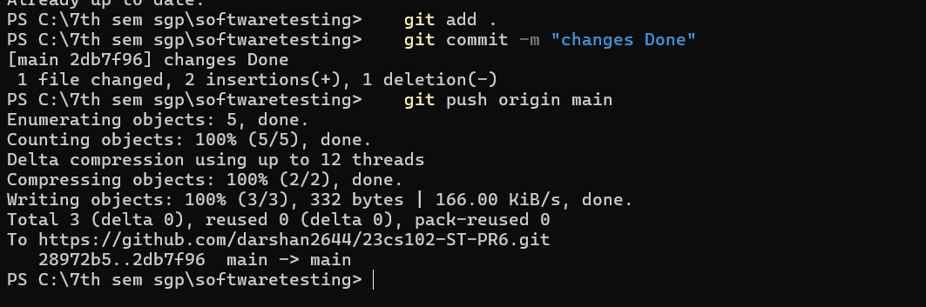

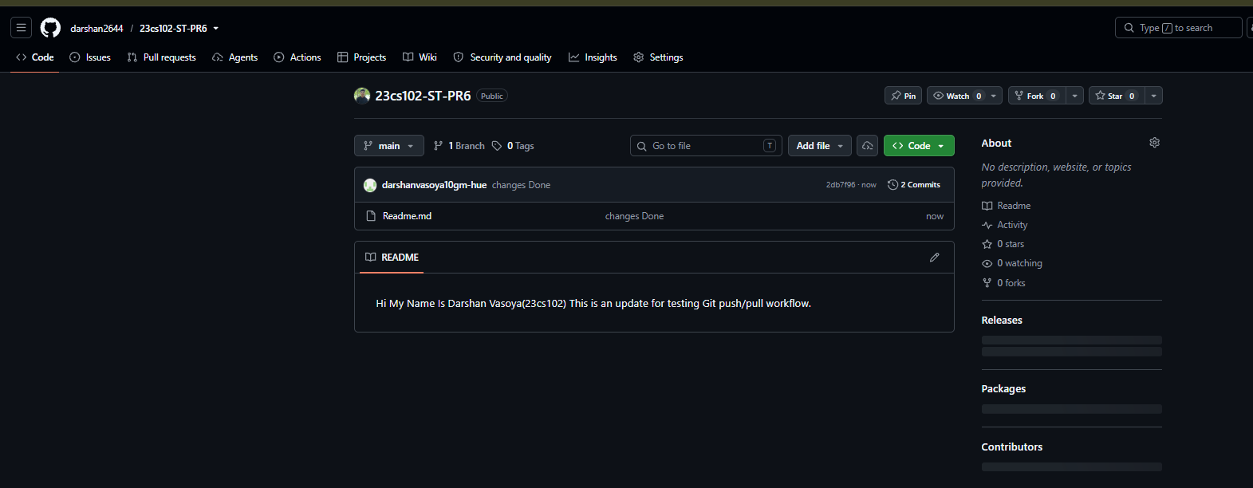

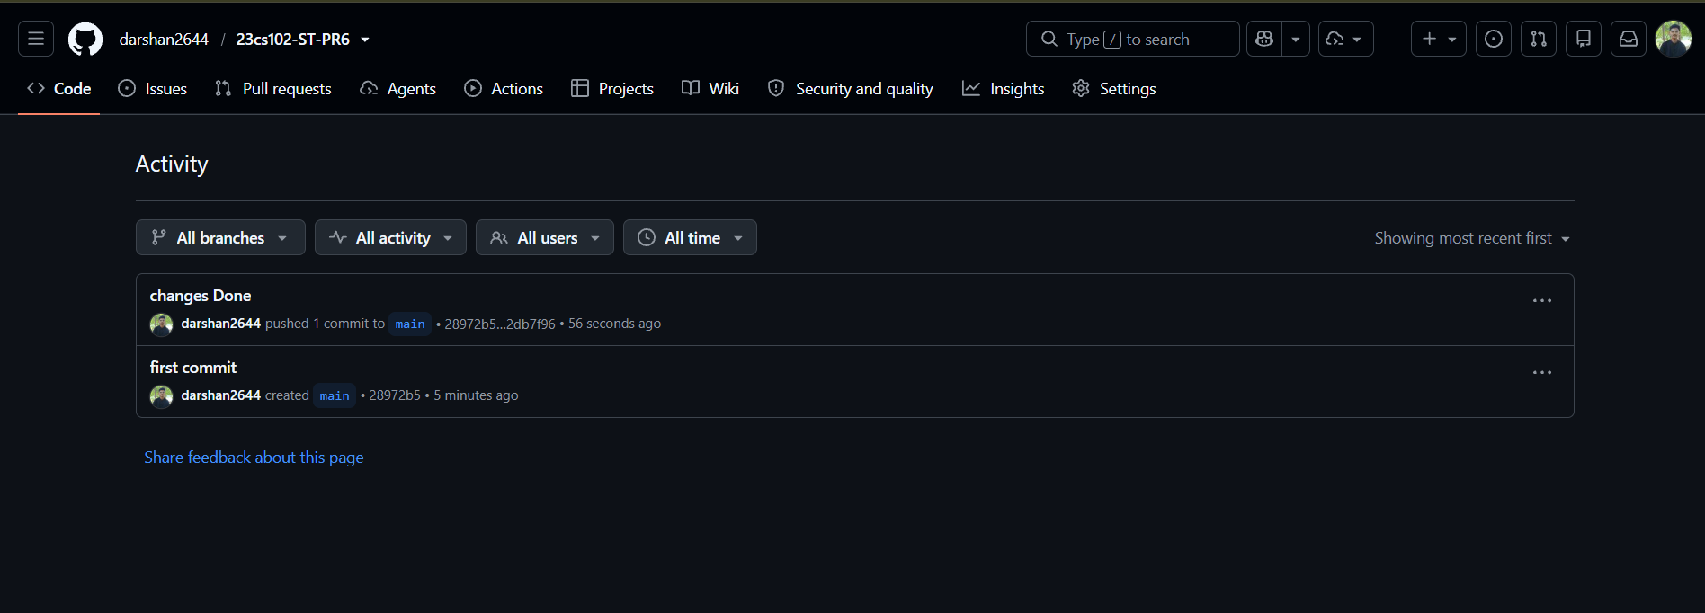

Finally changes in script is successfully commit to Github.
Reference Youtube Video:
https://www.youtube.com/watch?v=XOiZXdY-yzc

